Project 2
Employee Management System

CIS-17A
Section 42448
Michael Risher
June 8, 2014
I. Introduction:

Title: Employee Management System

Allows you to manage a table employees by edited, searching, deleting, setting hours worked, and viewing payment info for employees.

II. Summary

Project lines of code: 1738 ( 1808 counting the data importer )

This program is a system to manage employees. This system allows you to build a table of employees, load an existing employee table, list all the employee in the table, search through that table using any of the properties of the employee including their id, name, age, sex, and pay rate, delete employees by their id, edit employee data by their id, set the hours worked by the employee id, and view the payment info for employee.

III. Class Overview:

Person
Data Type | Name | Access | Description
String | Fname | Protected | First name of employee
String | Lname | Protected | Last name of employee
Int | Id | Protected | The unique id for each employee
Int | Age | Protected | The age of the employee
Int | Sex | Protected | The sex of the employee either 0 or 1
Employee
Float | Payrate | Private | The pay rate for the employee
Float | Hours | Private | The hours worked by the employee
Intern
Float | Payrate | Private | The pay rate for the employee
Float | Hours | Private | The hours worked by the employee
Bool | IsPaid | Private | If the intern is paid
Data
Int | TotalRecords | Private | Total number of records being stored
String | Filename | Private | The file where the records are being stored
vector<employee> | Employees | Private | Where employees data are stored
vector<Intern> | Interns | Private | Where interns data are stored
vector<Volunteer> | Volunteers | Private | Where volunteers data are stored

IV. Pseudocode:

start
ask for user action
if build
ask for the type of employee they want to enter
if type selected ask for user to input the appropriate data
save;
if load
get the file they want to load from read the entire file count all the people
rewind to the beginning and use the data
save;
if list
run through all the employee data and print it out
if delete
ask for the id
find the employee id and delete the record
if search
ask what find of search
if id
find the employee with the id and print out results
if first name
find the employee with partial string search and print out results
if last name
find the employee with partial string search and print out results
if age
find the employee by age and print out results
if pay rate
find the employee by pay rate and print out results
if hours
ask for the id of the employee
if exists ask for the hours to be set
set it
if payment
ask for the id of the employee or -1 for all
run get pay on all the affected employees excluding volunteers for obvious
reasons
if edit
ask for the id of the employee you want to edit

V. Flowchart:
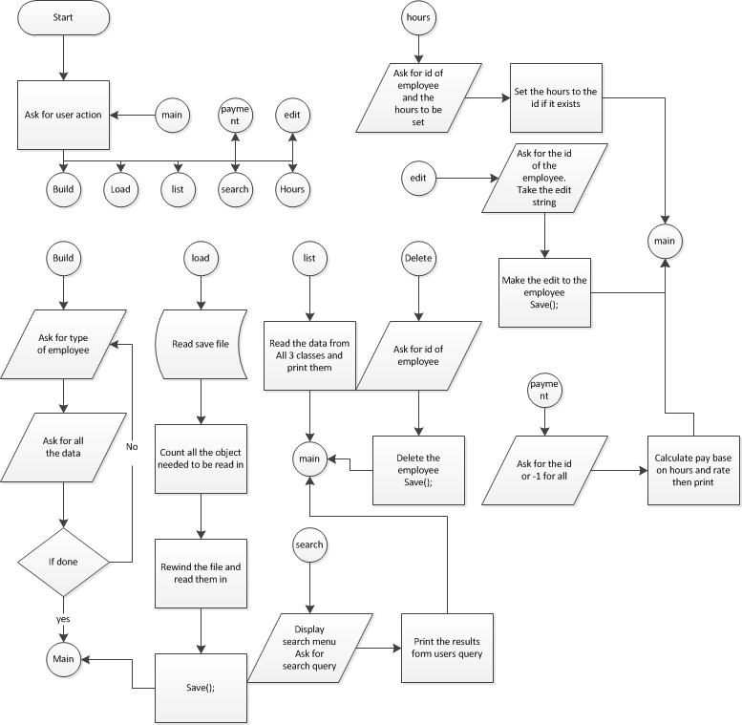
VI. Notes:

- The flowcharts are attached inside the project zip.

